

**NAME: PRIDE TANAKA CHAIPAH**

**REG NUMBER: H170424X**

**SCHOOL: INFORMATION SCIENCE & TECHNOLOGY**

**DEPARTMENT: INFORMATION TECHNOLOGY**

**PROJECT: HIT WEB-BASED ONLINE EXAM**

# DECLARATION

# DEDICATION

# ACKNOWLEDGEMENTS

# ABSTRACT

Online Examination faces many security threats. A student invites a third party for impersonation or assistance during the examination. So, an efficient invigilation mechanism is needed to ensure the standard of examination and to maintain authentic conduct of examination. In this system Facial Recognition is used to build such system that perform live identification and authentication of candidate throughout the examination to avoid impersonation. More importantly, the system continuously (with short time intervals), checks for learner identity during the whole exam period to ensure that the learner who started the exam is the same one who continued until the end. Additionality the system will prevent the possibility of cheating by looking at adjacent PC or reading from an external paper using face recognition such that if a student looks away from current screen it can flag as mal practice (time of student looking away is considered and analyzed). The system will issue an early warning to the lectures if suspicious behavior has been noticed by the system.

# Table of figures

# Table of tables

# List of Acronyms (Optional)

Proctoring: Invigilation

# CHAPTER 1 INTRODUCTION

## **1.1Introduction**

### A website is certainly a powerful bridge between students and educators because of features like security, affordability, easy accessibility, customization, quick content update, high scalability and cloud-based solutions for storage are the drivers of the virtual classroom. Facial recognition is a technology that involves classifying and recognizing human faces, mostly by mapping individual facial features and recording the unique ratio mathematically and storing the data as a face print

#### Image Proctoring is conducted for a locality where no stable internet connection is available or the bandwidth is unstable. Image proctoring will be the most essential security mechanism to prevent malpractices during the online exam.

## **1.2 Motivation**

* Prevention of mal practises during online examinations
* Increase in demand for online education due to the coronavirus hence online exams are required.
* An effective way of running more classes.
* Help block students not stay late at school writing exams.

## **1.3 Problem Statement**

In online exams the location of the proctor and examinee are at different locations since the communication is online using internet hence the increase in the distance, chances of doing malpractice increases and identification of misbehaviors of the examinees is quite difficult.

These Misbehaviors Include:

Location Constraint

Online Exams allows you with the freedom to appear from any remote location of your choice.

#### Freedom to browse the web and copy

An Online Exam from a remote location, sounds more like an invitation for an Open Book Test. A candidate might open any source of their choice and copy the answer content within minutes and as an examiner with the current system you don’t have any control over this malpractice, do you?

## **1.4 Related Work**

**DETECTION OF IMPERSONATION IN REMOTE ONLINE**

**EXAMINATION BY A TECHNICAL RESERCH COMPANY IN INDIA**

Facial recognition with PCA is a simple approach that can embedded to the existing system to conduct dynamic authentication of the candidate. Candidate registration photograph is used for comparison with the picture recorded while the candidate enters the examination hall.

**Architecture**



Candidate is asked to register using necessary details and recent photograph. A unique QR

code is generated for each candidate registered and is used for authentication of the candidate

and generation of unique question set for that candidate.

QR code has a square grid with white background on which a series of black squares are arranged, which can be read using any imaging device such as a camera and processed using Reed-Solomon error correction to interpret the image correctly without any noise or error. The data are extracted from the patterns formed by vertical and horizontal components of the image.

D.QR Code Scanner

The processor locates the three distinctive squares at the corners of the QR code. A smaller square at the last corner of the image is used to normalize the image for size, orientation and

angle of viewing. The small dots throughout the QR image are then converted to binary numbers

and validated with an error correcting algorithm.

Advantages of this System

* The bar code creates a unique id for each image hence It becomes easier to identify the image
* Less time consuming than traditional methods.
* It is used to detect whether the person is authorized to write the exams

Disadvantages

* Can be time consuming to implement the code Scanner

## **1.5 Hypothesis**

## **1.6 Technical Objectives**

* A system that can identify and recognise the right student to take an exam
* A system that does not allow switching of tabs when writing exam
* A system that can add an exam and allow student to answer on the same platform

## **1.7 Expected Results**

* A Face detection and recognition system for identity verification and attendance monitoring in the examination system
* A system that will be able to reduce malpractices of students during online examinations.
* A system that will allow teacher to add new exams, assignments and notes where students can write on the same platform and even have discussions when they have questions.
* A system that allows login using face recognition

## **1.8 Ethics Consideration**

Personal information like pictures of students taken by the system should be kept private and only visible by lecture and not the public i.e., other students.

## **1.9 Conclusion**

This system is essential as it will help students across various locations to communicate on one platform and reduce confidence in doing mal practises by students. This system will help students’ study because students tent to not study for online exams because they know they can easily cheat from notes.

# CHAPTER 2 REQUIREMENTS ANALYSIS

## **2.1 Introduction**

The system works online hance requires an internet connection for the facial recognition software. The system also requires good quality test images of students which are to be used with live images.

### 2.1.1 Evaluate Alternatives

### 2.1.2 Outsource (outline reasons why not)

### 2.1.3 Improvement (outline reasons why not)

### 2.1.4 Development (Why, justify in terms of costs from others)

## 2.2 User Requirements

### 2.2.1 Collection Phase

NB: Students should note that in this section we are mainly interested in the benefits derived from using a particular information gathering technique. The type of information solicited using each and every technique must be clearly spelt out so as to clearly show the different scenarios the techniques are used. The tendency to write notes is greatly prohibited where students tends to jot down all the advantages and disadvantages of a technique. Sample questionnaires and interview guides used should be included in the appendix section together with the sample answers received.

### **2.2.2 Technical Feasibility**

### **2.2.3 Hardware**

* Processor: Intel Dual Core or Advance.
* Hard Disk: Minimum 80 GB.
* Display: LCD/LED Color.
* Accessories: Web Cam, Keyboard & Mouse.
* RAM: Minimum 1 GB.

### **2.2.4 Software**

* Operating system: Microsoft Windows 7 or Higher Versions.
* Programming Language: python, php
* Database: MySQL

### **2.2.5 Technical Expertise**

In this System student will require technical support from supervisor Ms Hwata

## **2.3 Economic Feasibility**

This system requires zero costs of development and very little data for students accessing exams and assignments.

### **2.3.1 Cost Benefit Analysis**

### **2.3.2 Tangible Benefits**

* The system will Identify the student taking exam
* One platform with all student courses
* Facial recognition login
* Platform to wright exams

### **2.3.3 Intangible Benefits**

* Saves time for lectures because classes are on one platform
* Reduced cheating on students
* Encourage student to study harder
* Save time and money for students without travelling to school for exams

## 2.4 Operational Feasibility

### 2.4.1 Schedule Feasibility

## 2.5 Develop work plan

### 2.5.1 Work schedule

### 2.5.2 Gantt chart

## 2.6 Conclusion

# CHAPTER 3 SYSTEM ANALYSIS

## 3.1 Introduction

This system will help lectures proctor online exams by receiving notifications from the system in the event of malpractices by students. It also makes it easier for lectures to organise their exams and other posted materials like notes, assignments and discussion by date and subject.

## 3.2. Description of current system

The current system, google classroom for example, allows lectures to post assignments, notes, and exams. Students can either write on the same platform or add an existing document (i.e., import a word document from the local drive). Log in is done using school email and student password after getting a google classroom class code from the lecture. Time constraints are also monitored to ensure proper time submission of school work. There is however no physical identification of who signed in or sent the school documents whatsoever.

## 3.3 Analysis of existing system

### 3.3.1 Context diagram of the existing system

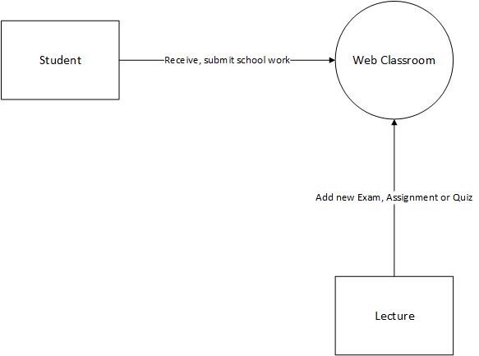

### 3.3.2 Weaknesses of current system

Student can wright tests for each other or submit assignments for each other by simply giving other students their google account passwords to log in. Increased mal practises, students can easily copy and paste information with confidence because no one is monitoring them.

## 3.4 Description of the Proposed Solution

In addition to the current system, lecture can identify if it was his or her student who wrote the exam through face recognition. System will offer exam proctoring to make sure that student is not cheating by copying and pasting or looking for answers on the phone and secure browsing is also enabled to restrict context switching between tabs

3.4.1 Analysis of the proposed system- Context diagram, DFDS

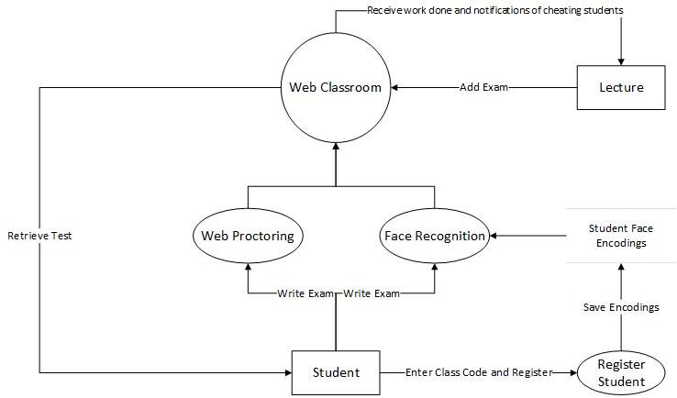

3.5 Requirements Analysis

3.5.1 Functional Requirements (use case diagram)

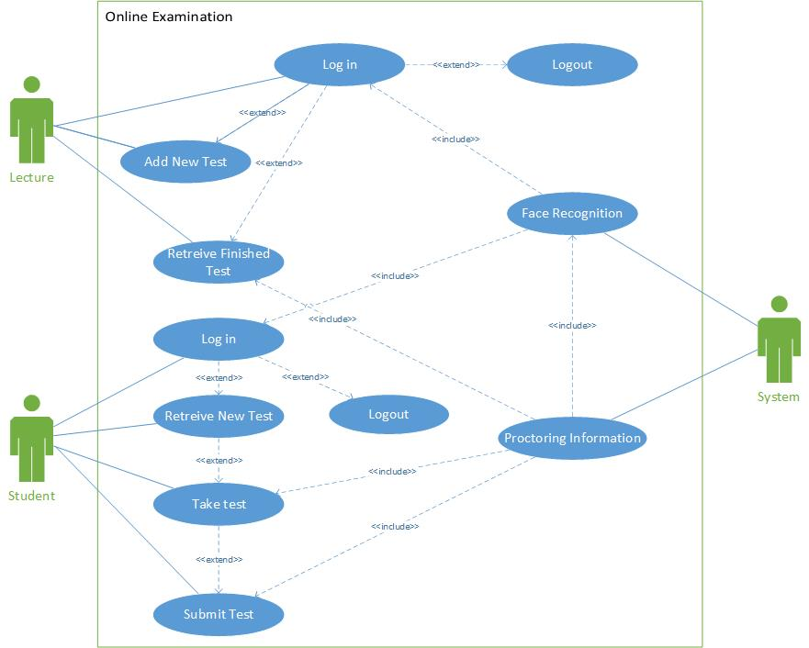

3.5.2 Non-functional requirements (outline constraints)

Efficiency

The system is highly depended on the lighting of the environment of the examinee because face recognition works different in different lighting areas therefore a constraint on distance in face match has to be set to period that allows varying areas because a face does not return a 100% match. This therefore means the system is more efficient in areas with brighter lighting

Security

The face recognition software allows robust security to the system to make sure only the right student or lecture has access to the class resources. Security breach however can occur in the case of twins who have similar faces but the research shows that only 50% of twins across the globe are similarly close enough to each other to be able to unlock their twin’s facial recognition log in.

Maintainability

The maintenance of the system will be managed through testing. Unit testing, system testing and integration testing hence our system is maintained.

Availability

The system is available in any location with an internet connection since it is web-based application. The service of the system should provide at every time.

### 

Performance

The system performs well depends on the processing unit of the current machine. Face recognition requires high processing power to scan various images and compare faces to test images therefore, machines like dual cores will take more time to detect faces than core i9 machines. With that been said, the system will perform quite well regardless.

### Portability

The System is portable because it is a web-based application.

Usability

Usability is the ease of use and learning ability of a software product. The system will be easy to use as the functionality in the system are only a few (i.e., viewing course, downloading assignments, writing exam) and the functionality is not new to many people.

Reliability

This system will be used for a classroom and not national coverage hence it will not have large loads of data that can strain the system performance or database hence it will be more reliable.

3.6 System Models

3.6.1 UML-Activity Diagram

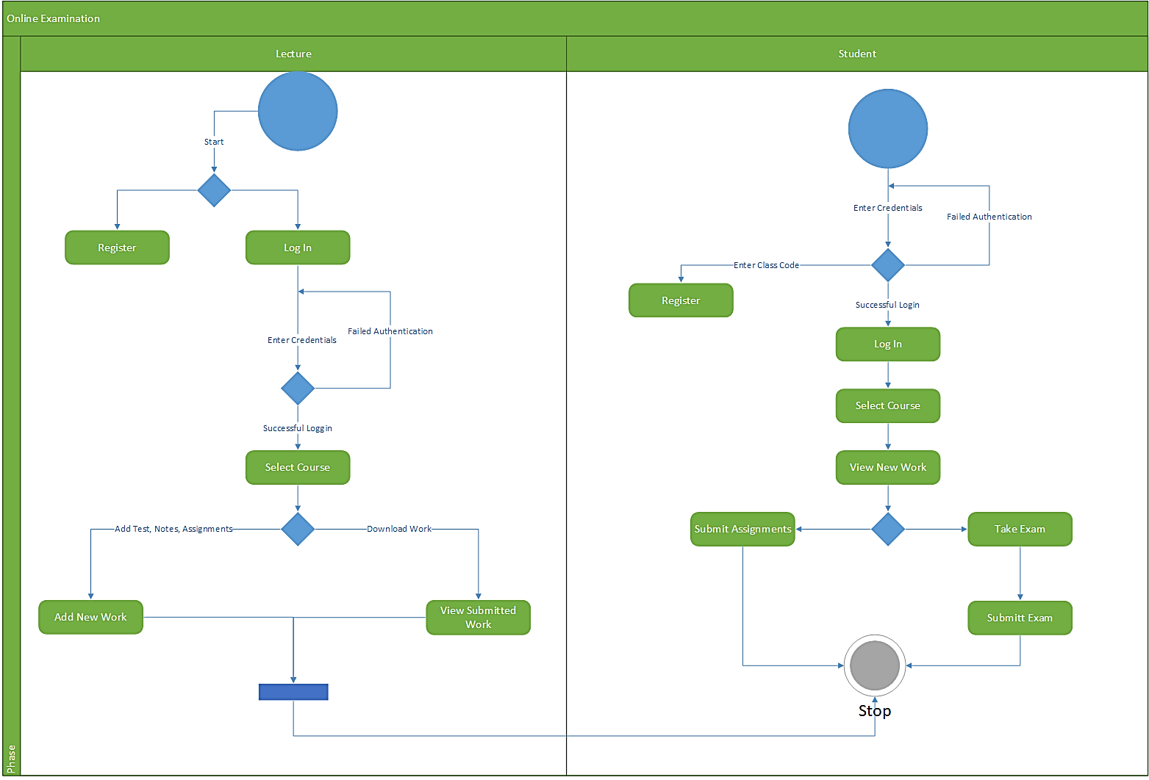

3.6.2 UML- Class Diagram

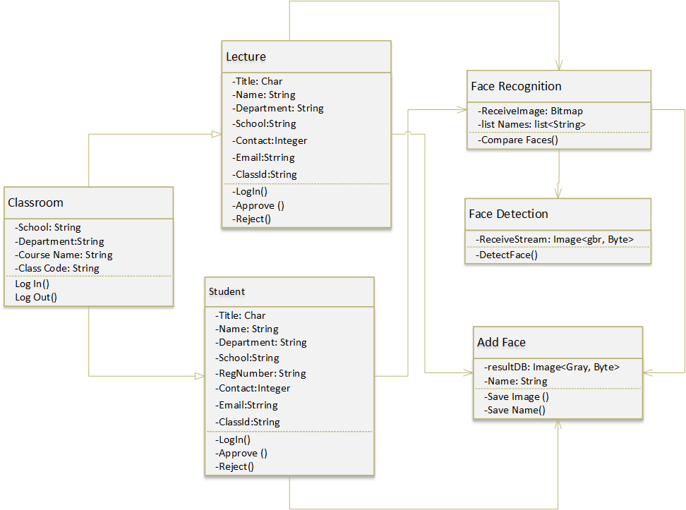

3.6.3 UML-Sequence Diagram (And any other relevant UML diagram)

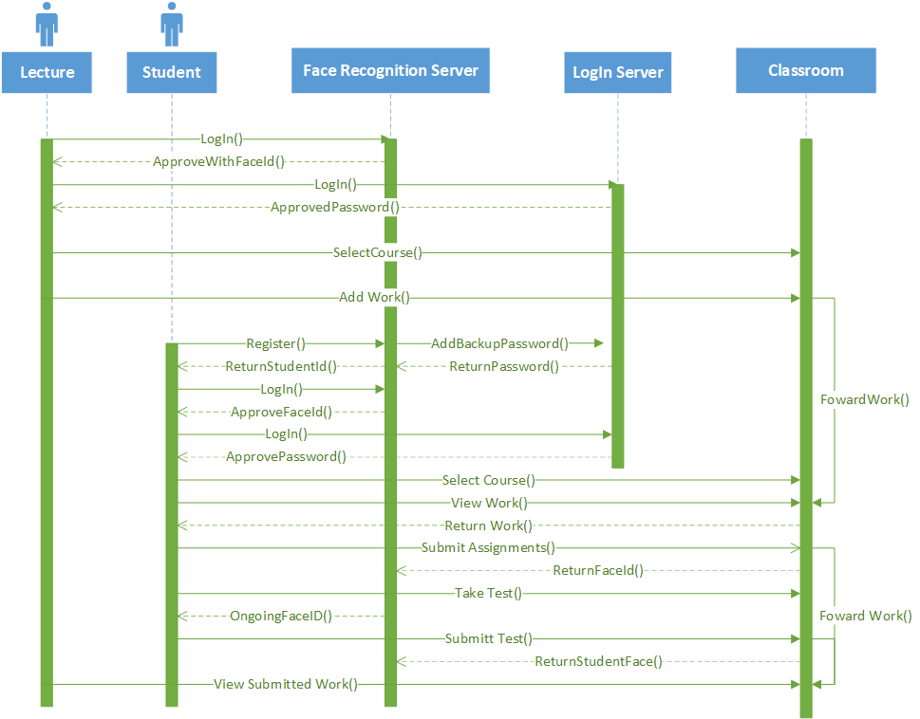

# CHAPTER 4: SYSTEM DESIGN

## 4.1 Introduction

## 4.2 System Design

### 4.2.1 How will the system work?

In this paper a multimodal technique is proposed for providing security. This includes authentication of the student at the beginning of the exam and later continuous monitoring of the student through webcam. The detection and comparison of the student’s face and behavior is done in two steps. Firstly, preprocessing is done to the image through filtering, normalization and segmentation. Later in the second step, feature extraction is done based on the color, texture and shape of the obtained image. With Image Proctoring, the system would capture a set of 30 to 90 images, based on the time or duration of the exam. For example, stipulated time for the exam is 90 mins, then you can arrange a set up where the system would capture 90 images of the candidate, an image per minute. The proctor would access this set of images stored on a cloud server at later point of time. And, the proctor can opt-out to report the candidate, if he/she happens to attempt any suspicious activity throughout the captured images of Online Exam. Secure browser is also used and it is nothing but a preventive mechanism which doesn’t allow the user to open an additional browsing window other than the one through which he/she is connected with the online exam activity.

#### How Secure Browser can help you secure online exam process?

Once a candidate starts with the online exam, he/she would not be allowed to access any extra tab or browsing window other than the one through which he/she is appearing for the exam.

If the candidate attempts to open an additional browsing window, an immediate notification would be sent to the exam controller sitting on the other end. The exam controller holds the authority to suspend the online exam for the candidate who just tried to breach the security enforcements.

## 4.3 Solution Architecture – architectural diagram of the proposed solution

## 4.4 Database Modelling

### 4.4.1 E-R Diagram

### 4.4.2 Data Dictionary

## 4.5 Algorithm Design

## 4.6 Interface Design

## 4.7 Security Design

## 4.8 Conclusion

# CHAPTER 5 IMPLEMENTATION AND TESTING

## 5.1 Introduction

## 5.2 Coding Strategy

## 5.3 Coding Review

## 5.4 Types of Testing and Results

### 5.4.1 Functional Testing

### 5.4.2 Non-Functional Testing

## 5.5 Test Cases

## 5.6 Levels of Testing and Results

### 5.6.1 Unit Testing

### 5.6.2 Integration Testing

### 5.6.3 Validation Testing

### 5.6.4 System Testing

## 5.7 Installation

### 5.7 1 User training

### 5.7.2 System conversion

### 5.7.3 File conversion

### 5.7.4 System changeover strategy

## 5.8 Conclusion

# CHAPTER 6 CONCLUSION

## 6.1 Scope for Future Extension

## 6.2 Maintenance

### 6.2.1 Interval System Review

### 6.2.2 Maintenance Activities

### 6.2.3 Disaster Recovery

## 6.3 Recommendations

# APPENDIX

# USER MANUAL

NB: A Technical paper is to be submitted together with this document.